STUART WEITZMAN SCHOOL OF DESIGN
UNIVERSITY OF PENNSYLVANIA
210 South 34th Street, Philadelphia, PA 19104

February 14, 2025

MEMORANDUM FOR THE MAYOR OF THE CITY OF LONDON

Jun, Youngsang
Master’s Student in Urban Spatial Analytics

SUBJECT: Recommendation of Congestion Charging in Western Zone

This memorandum recommends a careful approach to extending westward congestion charging from Central London, considering the following: First, given the high proportion of residents in western zone, explore ways to integrate the congestion charging policy with existing systems so that it does not feel like an additional regulatory burden to people. Second, introduce a two-zone system to effectively reduce traffic volume, but establish clear criteria to avoid confusion. Third, central and western zones have different key industries, which should be considered when implementing congestion charging.

1. Background

A western extension refers to “bringing all of the city of Westminster and almost all of the royal borough of Kensington and Chelsea into the charging zone (Gómez-Ibáñez, 2005)”. In 2003, as the introduction of congestion charging in Central London (also known as the original scheme), “Cars entering Central London during charging hours had declined by 33 percent and delivery vans and trucks by 11 percent, while exempt vehicles (taxis, buses, and motorcycles) had increased by 11 to 23 percent (Gómez-Ibáñez, 2005).” Public opposition to congestion charging also decreased from 41 percent before implementation to 28 percent after implementation (Gómez-Ibáñez, 2005).

Meanwhile, the western zone experienced higher levels of traffic congestion throughout the working day compared to areas to the north, south, and east of the central zone. While other areas also experienced heavy traffic congestion, this was more predominant at peak times (Transport for London, 2007). Transport for London projected that a £5 charge would reduce traffic entering the extension by 5 to 10 percent and congestion by 10 to 20 percent (Gómez-Ibáñez, 2005).

However, there are socio-demographic differences between central and western zones, and since the level of confusion and effectiveness may differ depending on whether the two-zone system operates simultaneously or one integrated zone system, these must be carefully reviewed to successfully implement the western expansion plan and maximize its intention.

2. Recommendations

a. Integrated Review with Existing Regulations

It is recommended to integrate congestion charging with other existing systems such as public transport incentives and vehicle registration regulations. The proposed western extension area includes 50 percent more residential neighborhoods than Central London (Gómez-Ibáñez, 2005), so it is even more important to actively accommodate the travel patterns and needs of residents than it is in Central London. If existing regulations (such as parking restrictions) excessively overlap with additional congestion charges, residents may feel it is unfair. If this issue persists, it may lead to policy failure. An integrated approach should balance incentives and penalties. One alternative is to exempt the western area from the next fare increase to encourage public transport use. Another option would be to offer residents of the western zone the same 90 percent discount as Central London, but limit the discount to only one vehicle per household, as many households in western zone own more than two vehicles (Gómez-Ibáñez, 2005). It is also recommended that a full penalty be imposed with no discount to encourage compliance.

b. Two-zone System with Clear Plan

In order to secure the effect of reducing traffic volume, it is recommended to introduce a two-zone system, but prepare a clear plan to minimize potential confusion. Introducing a two-zone system may cause confusion, as the Mayor has expressed concerns (Gómez-Ibáñez, 2005), but it is still necessary to enhance the effect of this policy. The total number of cars and vans in the western zone is 70,000, compared to 32,000 in Central London (Transport for London, 2007). “Separate zones would reduce the incentive for extension residents to drive into Central London, thereby protecting £10 million per year in congestion benefits and adding £5 to £10 million per year in revenue compared to a single expanded zone (Gómez-Ibáñez, 2005).” For example, if a discount is introduced exclusively for travel from central zone to western zone when a car has already traveled from the western zone to the central zone on the same day, it is expected to ease financial strain, encourage western commuters to use alternative transport options as well as provide clear guidelines for implementation.

c. Considering Western Zone Has a Different Industry Structure from Central Zone

It is recommended to consider the western zone has a different set of main industries from Central London as shown in Exhibit 1. The Central London had 50% of jobs in financial and business services, while the western zone had 29% (Transport for London, 2007). Also, The western zone had relatively higher representation in sectors such as retail, education and health, and hotels and restaurants (Transport for London, 2007). If the western extension is implemented without considering these issues, there is a risk of significant backlash compared to the original scheme. It is recommended to implement supplementary measures, such as vouchers for visitors who verify their congestion charge payment.

3. Conclusion

The success of the proposed western extension of congestion charging depends on addressing key differences in sociodemographic characteristics, traffic patterns, and economic structures between central and western zones. Since no one likes to pay for something they currently get for free, public acceptance requires integrating the charge with existing regulations, while a carefully structured two-zone system can help reduce congestion fairly. Consideration of the western zone’s distinct industries is also essential to avoid unintended economic impacts.

References

Gómez-Ibáñez, Jose (2005). Congestion Charging in London (A): The Western Extension. Kennedy School of Government Case Program. CR14-05-1787.0
Transport for London (2007). Central London Congestion Charging: Impacts monitoring Fifth Annual Report, July 2007.

Exhibit 1. Employee jobs by business sector in western extension, compared to the original central London charging zone and Greater London.

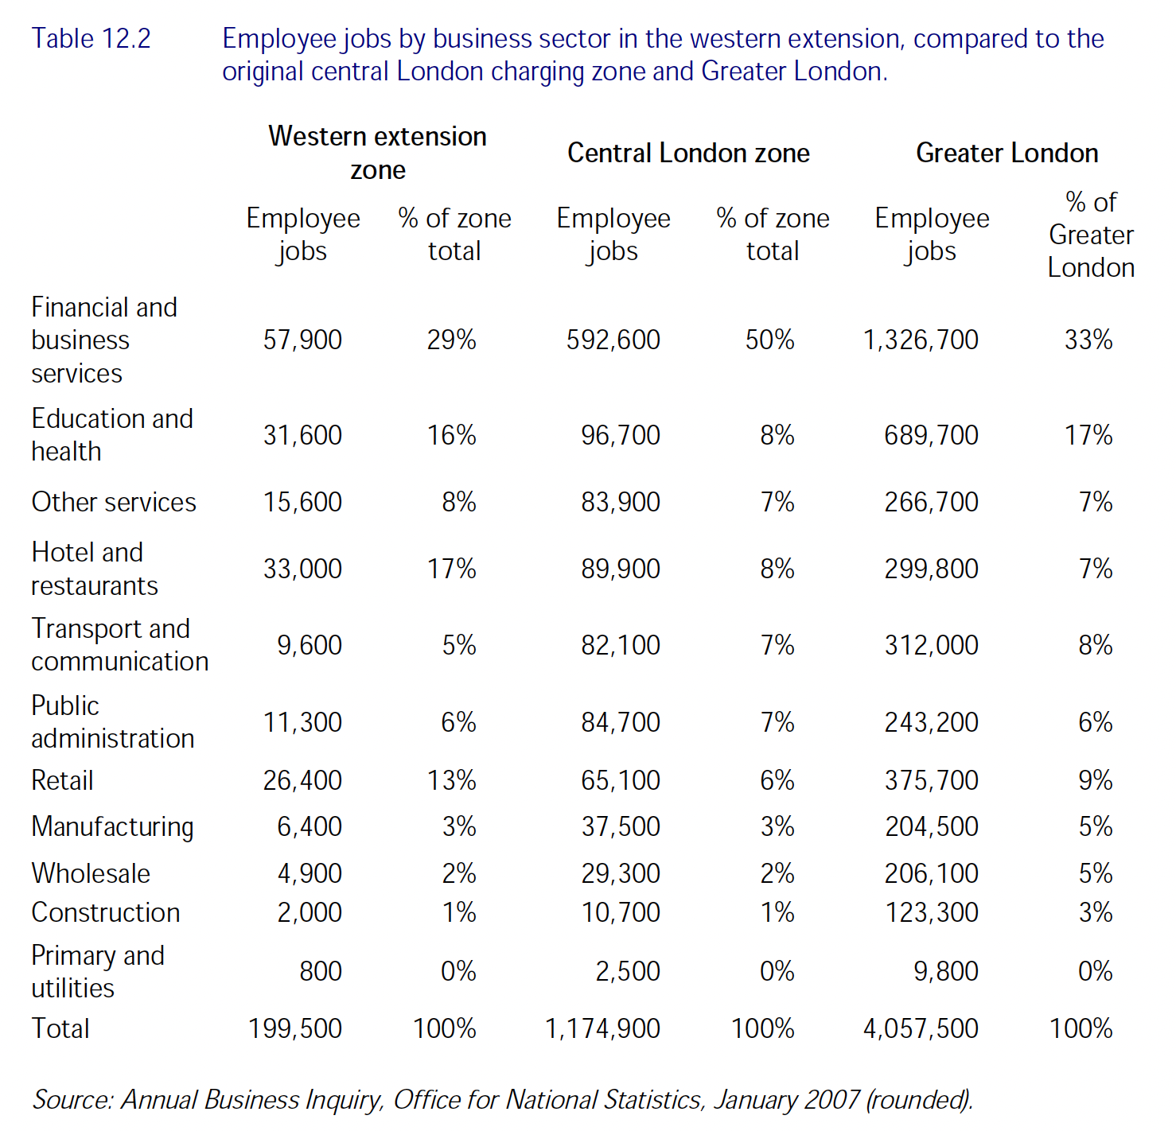

The average speed (minutes/kilometer): (i) Central London (before) 4.3, (ii) Central London (after) 3.6, (iii) West 3.7, (iv) East 2.6, (v) North 2.8, (vi) South 2.7 (Gómez-Ibáñez, 2005).

